* All button on view product is not access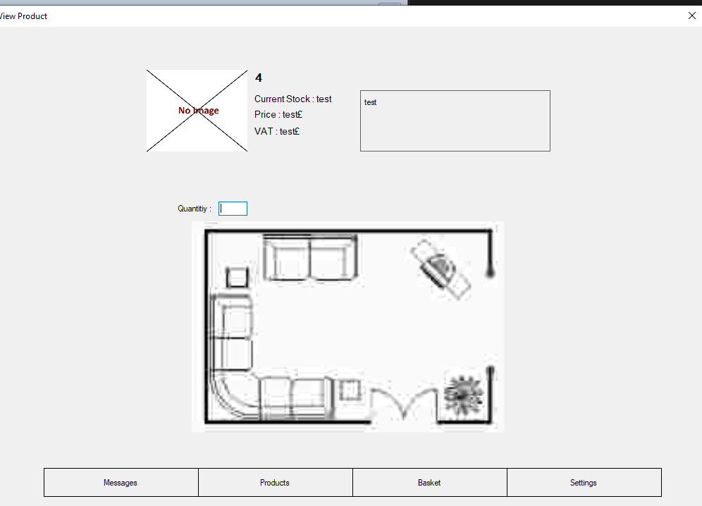
* Return item and check item out has same error message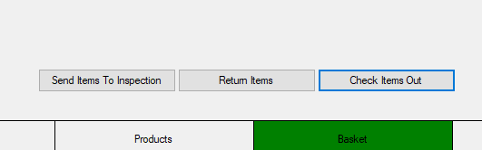
* Do not have an exit button, if close with “X”, system will re-run.
* How can return item on the basket?
* VAT should be 20% of the price
* Is Inspection doesn’t work?
* New shipment adds items row for?
* Admin settings new password for?
* Admin settings can create multiple same username user
* Admin settings cant judge user that create to admin or user

# Unit Test

Login

|  |  |  |  |
| --- | --- | --- | --- |
| **No** | **Title** | **Expected Function** | **Function Test** |
| 1. | Login Function | * Validate username and password from database | * Validate username and password from database |

Sign Up

|  |  |  |  |
| --- | --- | --- | --- |
| **No** | **Title** | **Expected Function** | **Function Test** |
| 1. | Sign Up Function | * Create a new user and save it to database equal a username, password and department | * Create a new user and save it to database equal a username, password and department |

## User

Message

|  |  |  |  |
| --- | --- | --- | --- |
| **No** | **Title** | **Expected Function** | **Function Test** |
| 1. | Information Function | * An announcement/ notification about shipment, expiring product, message and etc… |  |

Products

|  |  |  |  |
| --- | --- | --- | --- |
| **No** | **Title** | **Expected Function** | **Function Test** |
| 1. | Show Products Function | * All products load from database then shows in template with image and name | * All products load from database then shows in template with image and name |
| 2. | Search Function | * According the user input to look for items with similar product’s name | * According the user input to look for items with similar product’s name |
| 3. | Products Function | * Click on the product then show the product details | * Click on the product then show the product details |

Product

|  |  |  |  |
| --- | --- | --- | --- |
| **No** | **Title** | **Expected Function** | **Function Test** |
| 1. | Show Product Information | * Load the clicked product from database |  |
| 2. | Add to basket function | * A Check In/ Out button to add this item and quantity from user input to basket |  |

Basket

|  |  |  |  |
| --- | --- | --- | --- |
| **No** | **Title** | **Expected Function** | **Function Test** |
| 1. | View Check in Product | * A list to check product that user added |  |
| 2. | Return item Function |  |  |
| 3. | Check Out Item Function | * Calculate all the price that user need to pay * Clear all the basket item |  |

Settings

|  |  |  |  |
| --- | --- | --- | --- |
| **No** | **Title** | **Expected Function** | **Function Test** |
| 1. | New Password Function | * Set a new password for the user | * Set a new password for the user |

## Admin

Message

|  |  |  |  |
| --- | --- | --- | --- |
| **No** | **Title** | **Expected Function** | **Function Test** |
| 1. | Information Function | * Information about new delivery, new message or tasks need to do |  |

Products

|  |  |  |  |
| --- | --- | --- | --- |
| **No** | **Title** | **Expected Function** | **Function Test** |
| 1. | View Product Function | * Product that has been created and saved on database present on this page | * Product that has been created and saved on database present on this page |
| 2. | Choose Product Function | * Click a product to gain details about it | * Click a product to gain details about it |

Product

|  |  |  |  |
| --- | --- | --- | --- |
| **No** | **Title** | **Expected Function** | **Function Test** |
| 1. | Product Details Function | * Product details saved on database show in format | * Product details saved on database show in format |
| 2. | Check In/Out Function | * The product has been chosen add to basket with user quantity input * A dialog for jump to basket or not | * The product has been chosen add to basket with user quantity input * A dialog for jump to basket or not |
| 3. | Edit Map Location | * Mark a new place for this product storage place | * Mark a new place for this product storage place |
| 4. | Remove Product | * Delete this product’s details | * Delete this product’s details |
| 5. | Save Changes | * Save all the changed details | * Save any changed about current stock, price, VAT, supplier id or map. |

Inspection

|  |  |  |  |
| --- | --- | --- | --- |
| **No** | **Title** | **Expected Function** | **Function Test** |
|  |  |  |  |

Invoices

|  |  |  |  |
| --- | --- | --- | --- |
| **No** | **Title** | **Expected Function** | **Function Test** |
| 1. | Log Function | * Get the log between the two dates and department that admin chose. | * Get the log between the two dates and department that admin chose. |
| 2. | Clear Function | * Clear all the log on the template. | * Clear all the log on the template. |
| 3. | Add Row Function | * Add a format to insert item, product id, n number, date, quantity and charge. | * Add a format to insert item, product id, n number, date, quantity and charge. |
| 4. | Create and Send Invoice | * Create all the choosing log to invoice and save it. |  |

Expected Delivery

|  |  |  |  |
| --- | --- | --- | --- |
| **No** | **Title** | **Expected Function** | **Function Test** |
| 1. | Add Shipment Items | * Save all the details about shipment and item to lists | * Save all the details about shipment and item to lists |
| 2. | Add Row Function | * Add an item format | * Add an item format |

New Shipment

|  |  |  |  |
| --- | --- | --- | --- |
| **No** | **Title** | **Expected Function** | **Function Test** |

Basket

|  |  |  |  |
| --- | --- | --- | --- |
| **No** | **Title** | **Expected Function** | **Function Test** |
| 1. | Show Product | * Show the product that add to basket by admin | * Show the product that add to basket by admin |
| 2. | Clear All function | * Clear all the items in the basket. | * Clear all the items in the basket. |
| 3. | Send Item to Inspection | * Item that be selected will remove from basket and show in inspection. |  |
| 4. | Return Item | * Clear the selected item. (Imagine it has been returned) | * Clear the selected item. (Imagine it has been returned) |
| 5. | Check Out Item | * Check Out all the item in basket |  |

Settings

|  |  |  |  |
| --- | --- | --- | --- |
| **No** | **Title** | **Expected Function** | **Function Test** |
| 1. | New User Function | * Create a new account for user or admin then save in database |  |
| 2. | Update Department Function | * Save the department that created or deleted. |  |